**CSE2004 DATABASE MANAGEMEENT SYSTEM**

**PROJECT REVIEW REPORT**

**PHASE -2**

REGISTER No. 1: 19BCE0162

NAME 1: Apurva Sharma

REGISTER No. 2: 19BCE0914

NAME 2: Khushee Jain

EPJ SLOT: L13+14

Project Title: ONLINE RECRUITMENT NETWORK

Mobile Number: 83199 43063

Project Type: Application

**PHASE 1: Requirement Analysis**

**Note: Some tables are added/changed**

**Data Collection Stage:**

**List of Entity Sets:**

1. Company
2. Offer Letter
3. User
4. Job Seeker
5. Requisition
6. Interview
7. Skill
8. Interview_Type
9. Result

**Data Identification Stage:**

1. Company (Comp_id , Comp_name, Email_id, Comp_Type,Vacany,Post )
2. Offer Letter (Off_Id, Date, Incharge)
3. User(Username, Password, Login_Time, Logout_Time)
4. Job Seeker (Can_Id, Can_Name, Pesonal_Info, Experience,Contact_details)
5. Requisition (Package, Criteria, Req_Id)
6. Skill ( Qualification, Co_Curricular, Technical)
7. Interview (int_Id, Remarks, Date, Time,Venue )
8. Interview_Type(int_Type_Id, int_Type_Name)
9. Result (R_Id, Recruitment_status, Post, Salary)

**E-R Diagram:**

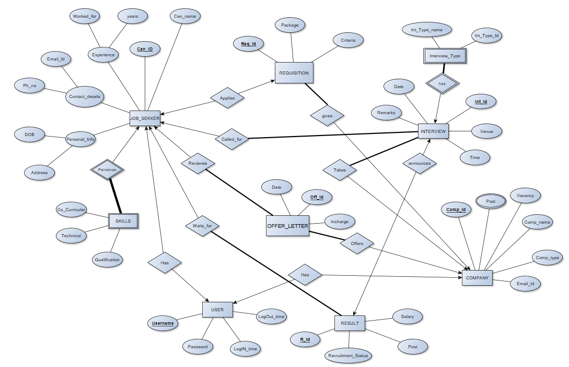

**Relationship Sets:**

1. Company (Comp_id , Comp_name, Email_id,Comp_Type,Vacany, Username)
2. Offer Letter (Off_Id, Comp_Id, Can_Id, Date, Incharge)
3. User(Username, Password, Login_Time, Logout_Time)
4. Job Seeker (Can_Id, Can_Name, DOB, Address, Email_Id, Ph_no, Worked_for,years, Offer_Id, Username)
5. Requistion (Package , Criteria, Req_Id, Comp_Id,Can_Id)
6. Skill (Can_Id, Qualification, Co_Curricular, Technical)
7. Interview (int_Id, Comp_Id, Remarks, Date, Time, Venue, Can_Id)
8. Interview_Type(int_Type_Id, int_Type_Name, int_Id)
9. Result(R_Id,Recruitment_status, Post, Salary, Can_Id, int_Id)
10. Posts(Comp_Id,Post)

**Schema:**

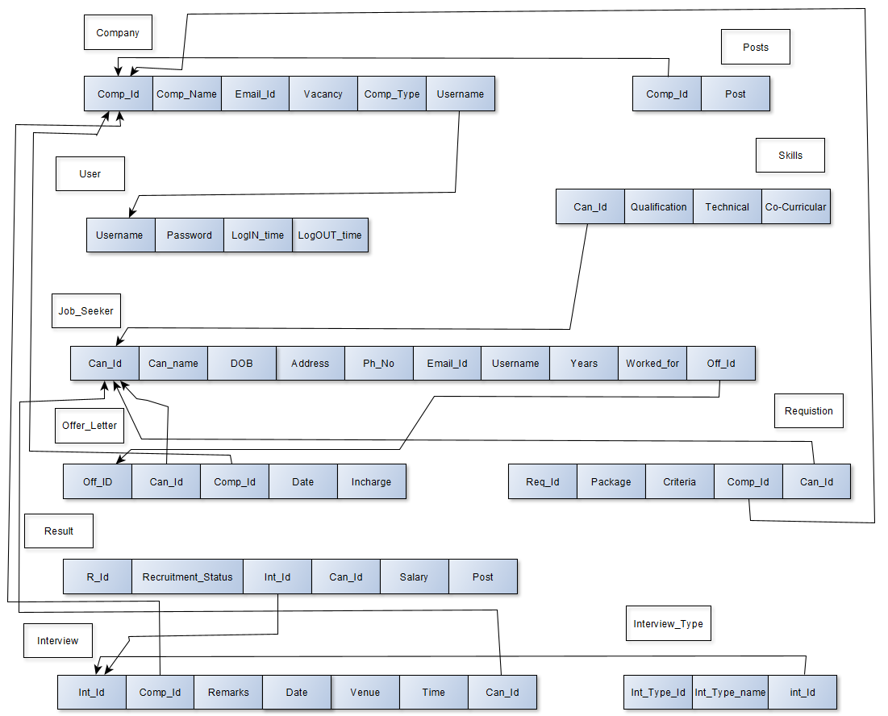

**PHASE 2:**

**Normalization:**

**Job Seeker**

|  |  |  |  |  |  |  |  |  |  |
| --- | --- | --- | --- | --- | --- | --- | --- | --- | --- |
| Can_id  **(A)** | Can_name  **(B)** | DOB  **(C)** | Address  **(D)** | Email_id  **(E)** | Ph_no  **(F)** | Worked_for  (**G)** | Years  (**H)** | Off_id  **(I)** | Username  **(J)** |
| J1 | Flynn Rider | 29-4-1990 | B104 Street A, California | flyn@ymail.com | 12654836 | Trello | 3 | O1 | Flynn_02 |
| J2 | Jake Harper | 25-5-1995 | C22 Street B, New Jersey | jke@ymail.com | 31177434 | Accenture | 4 | O2 | Jake_45 |
| J3 | Rodger S | 29-4-1997 | D23  Street A, Tawain | rodger@ymail.com | 39675369 | Hopper Technologies | 5 | O2 | Rodger_09 |
| J4 | Linda martin | 30-8-1990 | X3  Street A, India | linm@ymail.com | 34567889 | Safety  Travels | 2 | O3 | Linda_DJ02 |

**FD: A → B,C,D,E,F,J**

**E → A,B,C,D,F, J**

**J→ A,B,C,D,E,F**

**AG → H**

**EG→ H**

**JG →H**

**Candidate keys:** Since I is not dependent on any attribute it must be present in candidate key.

(AGI)+= A,G,I,H,B,C,D,E,F,J = R (AG → H, A → B,C,D,E,F,J)

(EGI)+= E,G,I,H,A,B,C,D,F,J = R (EG → H, E → A,B,C,D,F,J)

(JGI)+ = J,G,I,H,A,B,C,D,E,F = R (JG→ H, J → A,B,C,D,E,F)

Candidate keys are : { AGI, EGI, FGI, JGI}

Prime Attributes are: {A, E, F, G, I,J}

Non-prime attributes are: { B,C,D,H}

**Normalisation:**

1. Since all the attributes of this relation are atomic. The table is in 1 Normal Form.

2. **For 2NF:**

1. It should be in 1NF.

2. Elimination of partial key functional dependency.

Minimal Cover of FD’s : A → J, E→J, J→B, J→D, J→C, J → E, J→ F, EG → H

Now in J→ B,C,D,F partial dependency is present.

So, we will decompose this in a separate table as:

**Decomposition:**

R1→ J,B,C,D,F with FD’s: J→ B,D,C,F

R2→ A,E,G,H,I,J with FD’s: A→ J E→J J→E,A GJ→ H

R1 is in 2NF as it does not contain any partial dependency and it is in 1NF.

And candidate key for R2 is J as (J)+ = J,C,B,D,F = R1

In R2 we have GJ→H as partial dependency.

So, we will decompose the table as

R3→ G,H,J with FD’s: GJ→H

R4→ A,E,G,I,J with FD’s: A→J, E→J, J→EA

Here both R3 and R4 do not contain any partial dependency and are in 1NF thus they are in 2NF.

Candidate key of R3 is GJ as (GJ)+= G,J,H = R3

Candidate keys of R4 are AGI , JGI, EGI as their closure gives R4.

Final Tables are

R1→ J,B,D,C,F

R3 → G,J,H

R4→ A,E,G,I,J

**Checking lossless decomposition:**

* R1 Ո R3 = J

And J is the candidate key for R1. Hence, Decomposition into R1 and R3 is lossless.

* R3 Ո R4 = GJ

And GJ is the candidate key for R3. Hence, Decomposition into R3 and R4 is lossless.

* R1 Ո R4 = J

And J is the candidate key for R1. Hence, Decomposition into R1 and R4

is lossless.

3. **For 3NF:**

1. It should be in 2NF.

2. It should not contain any transitive dependency.

R1 do not contain any Transitive Dependency

Thus it is in 3NF.

R3 do not contain any Transitive Dependency.

Thus it is in 3NF.

R4 do not contain any Transitive Dependency.

Thus it is in 3NF.

**4. For BCNF:**

1. It should be in 3NF.

2. LHS of each FD should be candidate key or super key.

R1→ J,B,D,C,F

It is in BCNF as LHS is a candidate key in the FD: J→ B,D,C,F

R3 → G,J,H

It is in BCNF as LHS is a candidate key in the FD: GJ→H.

R4 → A,E,G,I,J with FD’s: A→J, E→J, J→EA

It is not in BCNF as LHS do not contain super keys.

So decompose the table into

R5 → G,I,J all the three attributes together forms a candidate key.

Therefore it is in BCNF.

R6→J,E,A with FD’s: J→ A,E A→ E,J E → J,A

Candidate keys are J , A, E as (J)+ =J,A,E (A)+ =J,A,E (E)+ =J,A,E

Since every dependency has LHS as a candidate key it is in BCNF.

Final Tables are: R1→ J,B,D,C,F

R3 → G,J,H

R5 → G,I,J

R6→J,E,A

**Interview_Type**

|  |  |  |
| --- | --- | --- |
| Int_type_id **(A)** | Int_type_name **(B)** | Int_id **(C)** |
| IT1 | Technical | I1 |
| IT2 | HR | I1 |
| IT2 | HR | I3 |
| IT1 | Technical | I4 |

**FD: A 🡪 B**

**B 🡪A**

**Normalization :**

1. Candidate keys: {CA, CB}
2. It’s already in 1 NF, 2 NF, 3 NF
3. For BCNF decompose into two tables: A ,C and A,B

(Int_type_id, Int_id) and (int_type_id and int_type_name)

**Interview**

|  |  |  |  |  |  |  |
| --- | --- | --- | --- | --- | --- | --- |
| Int_id **(A)** | Comp_id **(B)** | Can_id **(C)** | Remarks **(D)** | Date **(E)** | Time **(F)** | Venue **(G)** |
| I1 | C1 | J1 | Good | 28-Jun-2020 | 9: 00 | MB |
| I2 | C1 | J2 | Excellent | 28-Jun-2020 | 8: 00 | SJT |
| I3 | C2 | J3 | NI | 1-Jul-2020 | 9: 00 | SJT |
| I3 | C3 | J4 | Good | 4-Jul-2020 | 9: 30 | SJT |

**FD: A 🡪 B, D, C, E, F, G**

**B, C 🡪 A, D, E, F, G**

**E,F,G** **🡪 A, B ,C,D**

**Normalization :**

1. Candidate keys: {A, BC, EFG}
2. It’s already in 1 NF, 2 NF, 3 NF and BCNF
3. Hence final table is: Interview(Int_id, Comp_id, Can_id, Remarks, Date, Time, Venue )

With minimal functional dependencies:

Int_Id → Date, Time, Venue

Comp_id Can_id → Date, Time, Venue

Date Time Venue → Int_id, Comp_id, Can_id, Remarks

**Result**

|  |  |  |  |  |  |
| --- | --- | --- | --- | --- | --- |
| Result_id **(A)** | Post **(B)** | Salary **(C)** | Can_id **(D)** | Int_id**(E)** | Recruitement_status **(F)** |
| RID1 | Developer | 2000000pa | J1 | I1 | Waiting |
| RID2 | Product Manager | 2000000pa | J2 | I2 | Recruited |
| RID3 | Product Designer | - | J3 | I3 | Rejected |
| RID4 | Consultant | 1000000pa | J4 | I4 | Recruited |

**FD: A 🡪 B, C, D, E ,F**

**E 🡪 A, B, C, F, D**

**D 🡪 A, B, C**

**Normalization :**

1. Candidate keys: A ,D , E
2. It’s already in 1 NF, 2 NF, 3 NF and BCNF
3. Hence final table is: Skill(Result_id, Post, Salary , Can_id, Int_id, Recruitement_status) where the functional dependency is -

Result_id 🡪 Post, Salary , Can_id, Int_id, Recruitement_status

Int_id 🡪 Result_id, Post, Salary , Can_id , Recruitement_status

Can_id 🡪 Result_id, Post, Salary

**Posts**

|  |  |
| --- | --- |
| **Comp_Id** | **Post** |
| C1 | Consultant |
| C1 | Developer |
| C2 | Consultant |
| C2 | Manager |

No Functional Dependency hence the only candidate key is (Comp_Id, Post).

Thus it is 1NF, 2NF, 3NF and BCNF.

**Skill**

|  |  |  |  |
| --- | --- | --- | --- |
| Can_id **(A)** | Qualification **(B)** | Co_Curricular **(C)** | Technical **(D)** |
| J1 | M S | Design | C1 |
| J2 | M Tech | Creative Writing | C2 |
| J3 | B Tech | Societies | C3 |
| J4 | Ph. D | Sports | C4 |

**FD: A → B, C, D**

**Normalization :**

1. Candidate keys: A
2. It’s already in 1 NF, 2 NF, 3 NF and BCNF
3. Hence final table is: Skill(Can_id, Qualification, Co_Curricular, Technical ) where the functional dependency is -

Can_id 🡪 Qualification, Co_Curricular, Technical

**Requisition**

|  |  |  |  |  |
| --- | --- | --- | --- | --- |
| Req_id **(A)** | Package **(B)** | Criteria **(C)** | Comp_id **(D)** | Can_id **(E)** |
| R1 | 600000 | 2 | C1 | J1 |
| R2 | 700000 | 2 | C2 | J2 |
| R3 | 900000 | 1 | C3 | J3 |
| R4 | 500000 | 1 | C4 | J4 |

**FD: A 🡪 B, D, C, E**

**D, E 🡪 A, B, C**

**Normalization :**

1. Candidate keys: A, D, E
2. It’s already in 1 NF, 2 NF, 3 NF and BCNF
3. Hence final table is: Requisition(Req_id, Package, Criteria, Comp_id, Can_id) where the functional dependency is -

Req_id 🡪 Package, Criteria, Comp_id, Can_id

Comp_id, Can_Id 🡪 Req_id, Package, Criteria

**User**

|  |  |  |  |
| --- | --- | --- | --- |
| Username **(A)** | Password **(B)** | Login_time **(C)** | Logout_time **(D)** |
| Flynn | Hfsjcavakl | 22:00 UTC | 23:00 UTC |
| Jake | Vahjdjac | 20:00 IST | 21:00 IST |
| Rodger | Hwgyufe | 21:00 UTC | 23:00 UTC |
| Linda | Ahlbuciac | 19:00 IST | 20:00 IST |

**FD: A 🡪 B, C, D**

**Normalization :**

1. Candidate keys: A, D, E
2. It’s already in 1 NF, 2 NF, 3 NF and BCNF
3. Hence final table is: User(Password, Username, LogIn_time, LogOUT_time)

where the functional dependency is –

Username → Password LogIn_time, LogOUT_time

**Offer Letter**

|  |  |  |  |  |
| --- | --- | --- | --- | --- |
| Off_id **(A)** | Comp_id**(B)** | Can_Id **(C)** | Date **(D)** | Incharge**(E)** |
| O1 | C1 | J1 | 2 – 3 – 2001 | J . Murugan |
| O2 | C1 | J2 | 12 – 4 – 2001 | J . Murugan |
| O3 | C2 | J3 | 17 – 5 – 2001 | Dev Mehta |
| O4 | C3 | J2 | 2 – 3 – 2001 | Riya S |

**FD:** **A 🡪 B, C, D, E**

**B, C 🡪 A, D, E**

**Normalization :**

1. Candidate keys: A, B, C
2. It’s already in 1 NF, 2 NF, 3 NF and BCNF
3. Hence final table is: Offer Letter(Off_id, Comp_id, Can_Id, Date, Incharge) where the functional dependency is -

Off_id 🡪 Comp_id, Can_Id, Date, Incharge

Comp_id, Can_Id 🡪 Off_id, Date, Incharge

**Company**

|  |  |  |  |  |  |
| --- | --- | --- | --- | --- | --- |
| Comp_id **(A)** | Comp_name **(B)** | Email_id **(C)** | Comp_Type **(D)** | Vacancy  **(E)** | Username  (F) |
| C1 | Campp | campp@ymail.com | Travel | 3 | Campp012 |
| C2 | Trello | trello@ymail.com | Software | 2 | Trello56 |
| C3 | Embibe | embibe@ymail.com | Education | 2 | Embibie09 |
| C4 | TheTribe | thetribe@ymail.com | Software | 1 | TheTribe34 |

**FD : A 🡪 B, C, D, E,F**

**C 🡪 A,B,D,E,F**

**F→ B, C, D, E,A**

**B D→ A,C,E,F**

**Normalization :**

1. Candidate keys: {A, C, F, BD}
2. It’s already in 1 NF, 2 NF, 3 NF and BCNF

Hence final table is: Company (Comp_id , Comp_name, Email_id, Comp_Type, Vacany, Username)

With functional dependencies-

Comp_Id → Username

Username→Email_Id

Comp_name Comp_Type→ Username

Email_id → Comp_id , Comp_name, Comp_Type, Vacany

**Total number of Tables in the final schema: 14**

**Final schemas:**

1. Company (Comp_id , Comp_name, Email_id,Comp_Type,Vacany, Username)
2. Offer Letter (Off_Id, Comp_Id, Can_Id, Date, Incharge)
3. User(Username, Password, Login_Time, Logout_Time)
4. R1JobSeeker(Can_id, DOB, Address, ph_no )
5. R3JobSeeker(Worked_for, Years, Off_id)
6. R5JobSeeker(Username, Worked_for, Off_id)
7. R6JobSeeker(Username, Email_id, Can_id)
8. Requistion (Package , Criteria, Req_Id, Comp_Id,Can_Id)
9. Skill (Can_Id, Qualification, Co_Curricular, Technical)
10. Interview (int_Id, Comp_Id, Remarks, Date, Time, Venue, Can_Id)
11. R1Interview_type(Int_type_id, int_id)
12. R2Interview_type(int_type_id, int_type_name)
13. Result(R_Id,Recruitment_status, Post, Salary, Can_Id, int_Id)
14. Posts(Comp_Id, Post)